Name: Callejo, Jaff Raine Jay V. Date: November 27, 2025
Course, Year and Section: BSIT-2A

Assessment Laboratory
Bash Scripting + Container Simulation Lab

PART 1: Bash Scripting
Option B — Student Grade Calculator
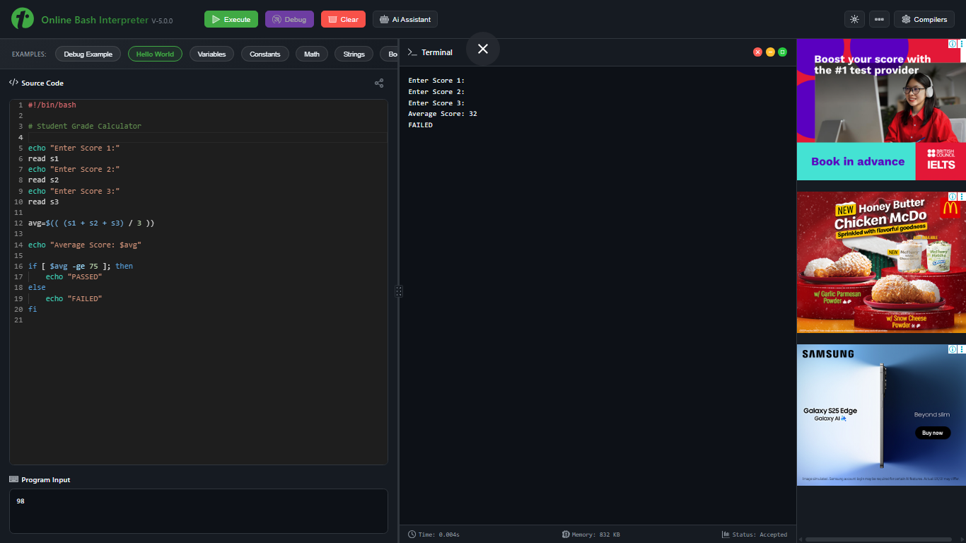
PART 2: Container Simulation Task
- Screenshot of pulling the image
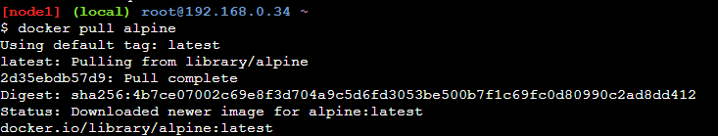
- Screenshot of running the container
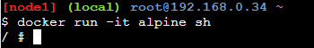

- Screenshot inside the container
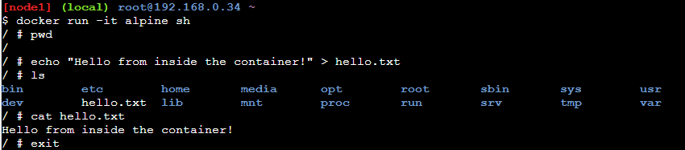

- Screenshot of listing and removing the container
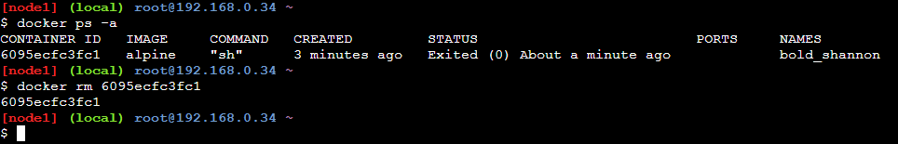
REFLECTION
During this activity, I learned how Bash scripting can automate simple calculations like computing an average and checking if a student passed or failed. I became more familiar with variables, user input, and if/else statements while testing the script in an online environment. At first, I made mistakes with arithmetic and spacing, but I learned that Bash is sensitive to syntax, so even small errors can stop the script from running.
For the container simulation, I finally understood how Docker works in terms of isolated environments. When I entered the Alpine container and saw the / # prompt, it felt like working inside a separate mini-computer. I learned basic Docker commands such as pulling an image, running a container, listing containers, and removing them. Creating and reading a file inside the container helped me see how containers can be used for testing without affecting my actual system. Overall, this lab improved my confidence in using command-line tools and understanding how automation and containerization are used in real-world setups.

